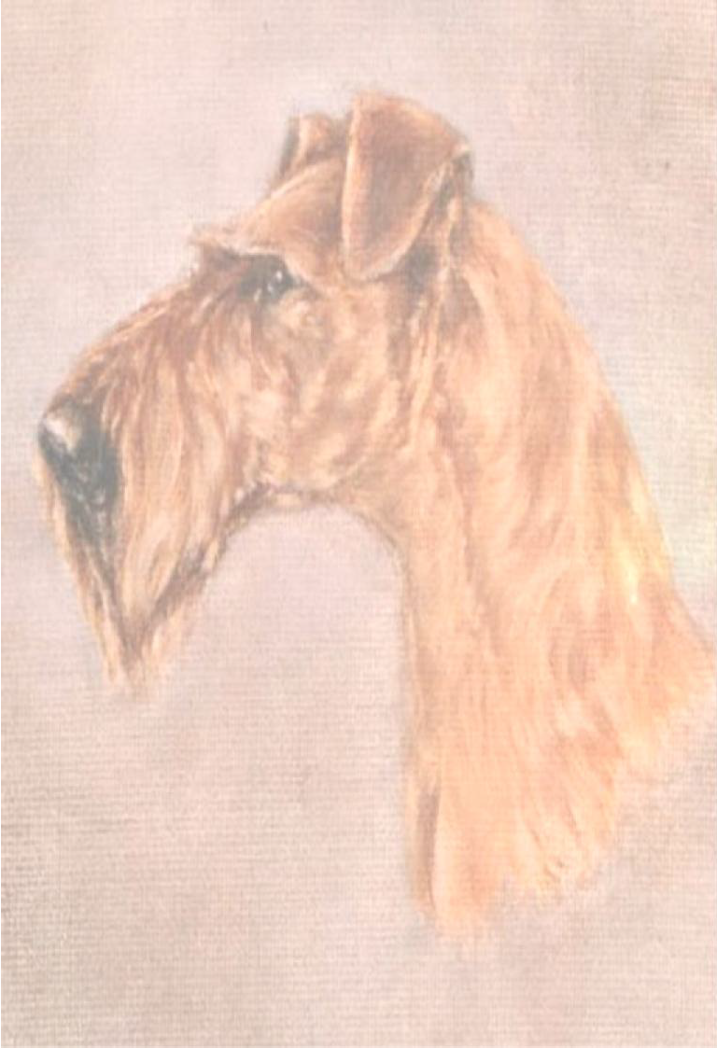THE NORTH OF ENGLAND IRISH TERRIER CLUB
Founded 1906

PATRON: Mr R Punter

SCHEDULE OF
Single Breed Unbenched

OPEN SHOW
Held under Kennel Club Limited Rules and Show Regulations
at
Lach Dennis Village Hall, Holmes Chapel Road,
Lach Dennis, Cheshire. CW9 7SZ
on
Saturday 13th April 2024
Show Opens:12.30pm Judging: 1.30pm
Preceded by the AGM at 11.30am

Judge: Stephen R Goodwin (Lanola)
All Judges at this show agree to abide by the following statement
“In assessing dogs, judges must penalize any features or exaggerations which they consider would be detrimental to the soundness, health and well being of the dog”
Show Manager - Mr.M Davies
Jurisdiction and responsibilities
The Officers and Committee members of the society holding the licence are deemed responsible for organizing and conducting the show safely and in accordance with the Rules and Regulations of the Kennel Club and agree to abide by and adopt any decision of the Board or any authority to whom the Board may delegate its powers subject to the conditions of Regulation F17. In so doing those appointed as officers and committee members accept that they are jointly and severally responsible for the organization of the show and that this is a binding undertaking (vide Kennel Club General Show Regulations F4 and 5).
ENTRIES TO :-
HON. SECRETARY: MRS W BOWER, 53 Forest Road, Cuddington, CHESHIRE. CW8 2ED TEL:01606 888534
Mobile Telephone on the day (Emergency only) - 07563914465

ENTRIES CLOSE Saturday 23rd March 2024 (Postmark)

ONLY UNDOCKED DOGS AND LEGALLY DOCKED DOGS MAY BE ENTERED FOR EXHIBITION AT THIS SHOW

ENTRY FEES
Each Dog: First Entry £3.00 Subsequent Entries £1.00 NFC (4 months plus) £1.00

MEMBERSHIP

Joint £9.00 Single £6.00

CATALOGUES : Prepaid with entries £2.00 - £2.50 on the day

ROSETTES FOR
1st, 2nd, 3rd, Res. in Each Class

BEST IN SHOW, RESERVE BEST IN SHOW
BEST DOG & BEST BITCH
BEST PUPPY AND BEST VETERAN

**PRIZE MONEY**

BEST IN SHOW: £20.00 BEST PUPPY:£10.00

REFRESHMENTS WILL BE AVAILABLE ALL DAY

ANY CONTRIBUTION TO THE RAFFLE WOULD BE MOST WELCOME

CLASSIFICATION

Judge – Stephen R Goodwin (Lanola)

CLASS 1. SPECIAL BEGINNERS DOG OR BITCH

CLASS 2. PUPPY DOG

CLASS 3. JUNIOR DOG

CLASS 4. NOVICE DOG

CLASS 5. POST GRADUATE DOG

CLASS 6. LIMIT DOG

CLASS 7. OPEN DOG

CLASS 8. SPECIAL BRED BY EXHIBITOR – DOG OR BITCH

CLASS 9. SPECIAL NOT BRED BY EXHIBITOR – DOG OR BITCH

CLASS 10. BEST VETERAN DOG OR BITCH

BEST DOG WILL NOW BE JUDGED

CLASS 11. PUPPY BITCH

CLASS 12 JUNIOR BITCH

CLASS 13. NOVICE BITCH

CLASS 14. POST GRADUATE BITCH

CLASS 15. LIMIT BITCH

CLASS 16. OPEN BITCH

BEST BITCH WILL NOW BE JUDGED

FOLLOWED BY

BEST IN SHOW & BEST PUPPY IN SHOW

DEFINITIONS OF CLASSES
In the following definitions a Challenge Certificate includes any Show award that counts towards the title of Champion under the Rules of any governing body recognized by the Kennel Club.
Wins at Championship Shows in breed classes where Challenge Certificates are not on offer shall be counted as wins at Open Shows.
In the case of a dog owned in partnership and entered in Members Classes or competing for Members Specials each partner must at the time of entry be a Member of the Club.
In estimating the number of awards won, all wins up to and including the seventh day before the date of closing of entries (i.e.
7th October2023) shall be counted when entering for a class,.
Wins in Variety classes do not count for entry in Breed classes but when entering in Variety classes, wins in both Breed & Variety classes must be counted. A first prize does not include a Special Prize of whatever value.
If an exhibitor reports before the judging of the class or classes that a dog has been entered which is ineligible, the exhibitor may choose one of the following options:
- Withdrawal. The dog may be withdrawn from competition subject to the conditions of Regulations F.(1 ).1920.
- Transfer. (a) If a dog is ineligible for a class or classes as regards its colour, sex, weight or height the Show Secretary shall transfer it to the equivalent class or classes for the correct colour, sex, weight or height and, in the event of there being no equivalent class, Minor Puppy and Puppy excepted to the Open Class for the correct colour, sex, weight or height
- For an exhibit entered incorrectly in a Minor Puppy class, Puppy class or Junior class, which is over age but under twelve calendar months of age, eighteen calendar months of age or 24 calendar months of age respectively, the Show Secretary shall transfer the exhibit to the Puppy Class, Junior Class or Yearling Class respectively for the correct breed, colour, sex, weight or height and in the event of there being no Puppy, Junior or Yearling Class to the Open Class for the correct colour, sex, weight or height.
- For any reason other than the above the Show Secretary shall transfer it to the Open Class for the correct, colour, sex, weight or height.
- If an exhibit arrives late and misses a class even if it is the only class in which the dog is entered, the dog may not be transferred to any other class.

MINOR PUPPY For dogs of six and not exceeding nine calendar months of age on the day of the Show

PUPPY For dogs of six and not exceeding twelve calendar months of age on the day of the Show. JUNIOR For dogs of six and not exceeding eighteen calendar months of age on the day of the Show.
NOVICE For dogs which have not won a Challenge Certificate/CACIB/CAC/Green Star or three or more First Prizes at Open and Championship Shows (Minor Puppy, Special Minor Puppy, Puppy and Special Puppy classes excepted, whether restricted or not).
POST For dogs which have not won a Challenge Certificate/CACIB/CAC/Green Star or five or more GRADUATE First Prizes at Championship Shows in Post Graduate, Minor Limit,
Mid Limit, Limit and Open classes whether restricted or not at Shows where Challenge Certificates were offered for the breed.
LIMIT For dogs which have not become show Champions under the Kennel Club
Regulations or under the rules of any governing body recognized by the Kennel Club or won 7 or more First Prizes in all at Championship Shows in Limit or Open Classes confined to the Breed, whether restricted or not at Shows where Challenge Certificates were offered for the Breed.
OPEN For all dogs of the breed for which the class is provided and eligible for entry at the Show.
VETERAN For dogs of not less than 7 years of age on the first day of the show..
SPECIAL
BEGINNERS For owner, handler or exhibit not having won a first prize at any Championship Show where Challenge Certificates were offered for the breed.
SPECIAL BRED BY EXHIBITOR – OPEN
SPECIAL NOT BRED BY EXHIBITOR - OPEN

REGULATIONS FOR THE PREPARATION OF THE DOGS FOR EXHIBITION F(B)
1, These Regulations must be observed when a dog is prepared for exhibition and/or
exhibited at any Kennel Club Licensed event. Objections may be referred to the General Committee for disciplinary action under these show regulations and/or for disciplinary
action under Kennel Club Rule A11
- A dog found to have been exhibited in breach of these Regulations will
automatically be disqualified from exhibition at the show and from any award gained thereat.
- Unless the exhibitor provides a satisfactory explanation for the dog being exhibited in breach of these Regulations then he/she may be subject to further penalties of either a fine or as listed under Rule A11
2(a) No substance which alters the natural colour, texture or body of the coat may be
present in the dog’s coat for any purpose at any time during the Show. No substance which alters the natural colour of any external part of the dog may be present on the dog for any purpose at any time during the Show
(b) Any other substance (other than water) which may be used in the preparation of a dog for exhibition must not be allowed to remain in the coat or any other part of the dog at the time of exhibition.
- No act or operation which alters the natural conformation of a dog or any part thereof may be performed except:
- Operations certified to the satisfaction of the General Committee.
- The removal of dew claws of any breed.
- Operations to prevent breeding provided that such operations are notified to the Kennel Club before neutered dogs are shown.
Nor must anything be done calculated to in the opinion of the General Committee to deceive.
- The General Committee without previous notice may order an examination of any dog or dogs at any Show. Any examination thus ordered will be made by a person having
executive authority who shall have a written directive from the Kennel Club in their possession. Samples may be taken for further examination and analysis
- An individual has the right to lodge an objection to a dog only if he/she is the owner or handler of a dog competing in the same breed or class. An objection may, however, be lodged by an official of the Show or by anyone so deputed by the Kennel Club. It will be the responsibility of the individual who lodges the objection or the official (as appropriate), to substantiate the grounds for the objection. The Kennel Club will substantiate the grounds for an objection made on its behalf.
- Any objection by an individual related to an infringement of these Regulations must be made in writing to the Show Secretary at his/her office before the close of the show and the individual must produce evidence of identity at the time of lodging the complaint.
REMEDIAL ACTION WILL BE TAKEN IN THE EVENT OF DOGS LEFT IN VEHICLES BEING FOUND IN A DISTRESSED STATE

DOG FOULING: Any owner, exhibitor or other person in charge of a dog is requested to remove as soon as possible any fouling caused by their dog/s

SHOW RULES AND REGULATIONS

- The Show will open at 12.30pm
- Dogs will be received at any time but it is the exhibitors responsibility to ensure that exhibits are available for judging when required.
- Judging will commence at 1.30pm
- Exhibits may be removed from the Show after their judging has been completed. The Show will close half an hour after all judging has been completed.
- The Entry Fee for each dog is £3.00 .Subsequent Classes £1.00. NFC £1.00. Puppies four months and over can be admitted to the show as NFC.
- Prize Money: BIS £20.00 BP £10.00
- The Committee reserves to itself the right to refuse entries.
- Puppies under six months of age on the day of the Show are not eligible for exhibition. 9.The mating of bitches within the precincts of the Show is forbidden.
- BEST PUPPY IN SHOW - Where a Best Puppy in Show Competition is scheduled the Best Puppy in Show is a Puppy which has competed and is unbeaten by any other puppy exhibited at the same Show. A Puppy is a dog of six and not exceeding twelve calendar months of age on the day of the Show. Where the Best in Show is a puppy it should automatically be awarded Best Puppy in Show. Where the Reserve Best in Show is a puppy which has only been beaten by an adult dog it will also automatically be Best Puppy in Show. Consequently, selection of Best Puppy in Show must follow the selection of Best in Show.
- BEST IN SHOW - Best in Show must be selected from the exhibits declared Best of Sex..If a Reserve Best in Show is to be selected, the eligible dogs are those declared Best Opposite Sex and Reserve Best of Sex to the exhibit declared Best in Show.
- Exhibits will not be admitted to Best in Show competition after a period of 10 minutes has elapsed since the announcement that exhibits are required for judging, unless they have been unavoidably delayed by previous judging not being completed on time, and then only with the special permission of the Show Management.
- Exhibitors must not pick up dogs by their tails and leads when lifting them. Nor handle a dog in a manner which causes its feet not to touch the ground when on the move. This is not acceptable. Exhibitors should note that such practice would constitute harsh handling and reports of such practice will be referred to the Committee under Kennel Club Show Regulation F11.
- All exhibitors must be familiar with Kennel Club Regulation F (Annex B) Regulations for the Preparation of Dogs for Exhibition.
- All dogs resident outside the UK must be issued with a Kennel Club Authority to Compete number before entry to the show/event can be made. All overseas entries without an Authority to Compete number will be returned to the exhibitor/competitor.
- Dogs in vehicles on Hot Days. Your dog is vulnerable and at risk during hot weather and the Kennel Club offers the following guidance to help guide you through the do’s and don’ts travelling to and whilst at KC licensed events.
*When travelling to a show please take a moment to consider whether the route to the show is on a busy holiday route, and leave earlier to avoid increased time in traffic jams.
*If your vehicle is not air conditioned seriously consider whether travelling to the show is a good idea at all.
*The vehicle should be as fully ventilated as possible, and plenty of stops should be taken with lots of water available to drink.
*Ensure your dog is not sitting in full sunlight. There should be plenty of free flowing air around the dog.
*When at the show, never leave the dog in the vehicle.
*Keep the dog in the shade– take your own shade for example a large umbrella and always have plenty of water available to drink so your dog stays well hydrated.
*Avoid your dog taking part in unnecessary exertion, or from standing in exposed sunlight for extended lengths of time.
Remember if you feel hot your dog is likely to feel much hotter and dehydrated, and this could
lead to dire results. Please look after your dog’s welfare.

- Anyone whose dog is entered at a Kennel Club licensed event should take all reasonable steps to ensure the needs of their dog(s) are met, and should not put a dog’s health and welfare at risk by any action, default, omission or otherwise. Breach of Kennel Club Regulations in this respect may be referred to the Board for disciplinary action under the Kennel Club Rules and Regulations. The use of pinch collars, electronic shock collars, or prong collars, is not permitted at any show licensed by the Kennel Club. This shall apply at the venue or within the precincts of the show.
- Not for Competition entries will be accepted. Details of each dog so entered must be recorded on the Entry Form and must be Kennel Club registered.
- No modifications will be made to the schedule except by permission of the Board of the Kennel Club which will be followed by advertisement in the Canine Press wherever possible.
- Exhibitors passes will not be sent, if a receipt of entry is required, please enclose a s.a.e. with your entry.
- The Committee will not be held responsible for the loss or damage to any dog or other property, whether arising from accident or any other cause, nor from any act or omission of themselves, their Officers, Servants or Agents or others and it is on this understanding that entries are accepted.
- No animal other than an exhibit shall be brought into the precincts of a Dog Show during its continuance, except any dogs registered to assist the disabled, or dogs required for educational or instructional purposes or by permission of the General Committee.
However, at the discretion of the show society, a dog brought to the show by a
spectator may be admitted into the precincts of the dog show, with the proviso that those in charge of the dog sign a declaration confirming the dog is free from disease and that the dog will be kept under proper control at all times.
- In the case of a dog owned in partnership and entered in Members' classes or competing for Members' Specials, each partner must at the time of entry be a member of the Club.
- The Committee of the Show can accept no responsibility for products advertised or sold by stand holders at the Show and remind exhibitors that grooming products on sale may not
meet the requirements of the regulations for the preparation of dogs for exhibition.

WARNING; IF YOUR DOG IS FOUND TO BE AT RISK FORCIBLE ENTRY TO YOUR VEHICLE
MAY BE NECESSARY WITHOUT LIABILITY FOR ANY DAMAGE CAUSED

Directions to venue
The hall is situated on the B5082 in the centre of the village. Leave M6 at Junction 19, take the A556 towards
Northwich and Chester,

After approximately 23/4 miles continue on the A556 as it bears left towards Chester.

In a further 11/2 miles (ignoring first sign to Lach Dennis)
immediately BEFORE roundabout turn left into Pennys Lane B5082, to Lach Dennis.

The Village Hall is 11/2 miles on the right hand side just past The Cheshire Steakhouse.
- - - - - - - - - - - - - - - - - - - - - - - - - - - - - - - - - - - - - - - - - - - -
FUTURE SHOW DATES

CHAMPIONSHIP SHOW

3RD NOVEMBER 2024

JUDGE: MRS CAROL BAMSEY (HOLBAM)

PLEASE ENSURE THAT ALL ENTRANCES/EXITS TO THE VENUE ARE KEPT CLEAR FOR UNLOADING AND IN THE CASE OF AN EMERGENCY
Please do not obstruct gangways with cages, pens, grooming tables, trolleys and dogs. Storage space will
be made available for trolleys/ cages.

